Cradlepoint as WIFI Bridge/Routers

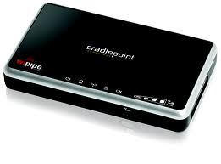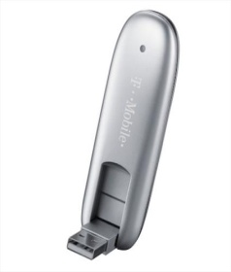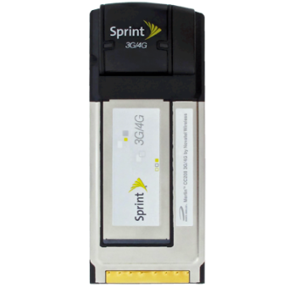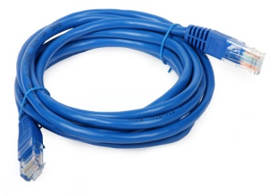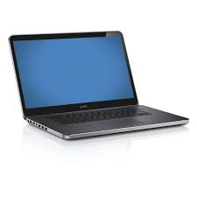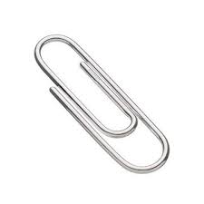

- Connect power & Ethernet cord into Cradlepoint device
- Use Port 1 is there are multiple ports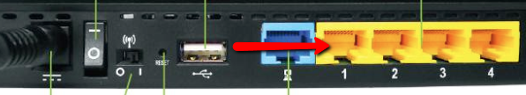
- Connect other end of Ethernet cord into laptop
- Disconnect from any Wi-Fi connections on laptop, or disable Wi-Fi
- Reset your Cradlepoint with a paper clip, hold down for approximately 10 seconds
- Wait 1-3 minutes until lights on Cradlepoint are solid
- Insert 3G USB or Sprint Data Card and wait 3 minutes
- Open up a browser on your laptop, preferably Chrome or Firefox
- Type in 192.168.0.1 in the address bar and press enter
- When prompted for password, use the last 8 characters of the MAC address located on the bottom of the Cradlepoint device
- Click on the Internet tab, and in the drop down select Connection Manager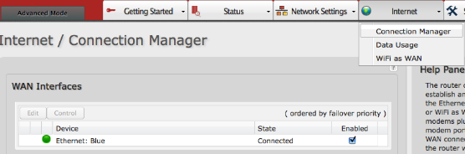
- Uncheck “WiMax” if Enabled
- Connect Ethernet cord to media player and reboot

CRADLEPOINT AS WIFI BRIDGE/ROUTER

- CONNECT THE POWER CABLE INTO THE CRADLEPOINT ROUTER
- CONNECT ONE END OF THE ETHERNET CABLE TO ONE OF THE YELLOW PORTS OF THE ROUTER
- CONECT THE OTHER END OF THE ETHERNET CABLE TO YOUR LAPTOP
- OPEN UP A BROWSER AND TYPE IN 192.168.0.1 AND HIT ‘ENTER’
- YOU’LL GET PROMPTED TO ENTER A PASSWORD; ENTER “admin” and validate
- ON THE TOP MENU GO TO INTERNET AND CLICK
- ON THE DROP DOWN LIST GO TO wifi as wan AND CLICK
- THE NEW PAGE WILL INCLUDE A SITE SURVEY AND IF TYOU WAIT FOR ABOUT A MINUTE, A LIST WILL APPEAR WITH ALL THE WIRELESS NETWORKS IN YOU AREA
- SELECT THE APPROPRIATE NETWORK AND DOUBLE CLIK ON IT
- A “ Profile Editor” (which is settings) APPEARS WITH A LIST OF THE NETWORK NAME, THE BSSID, THE AUTHENTICATION MODE AND TYPE AND A SLOT FOR A PASSWORD; TYPE THE PASSWORD PROVIDED BY THE NETWORK ADMINISTRATO, IE THE LOCATION AND CLICK ON SUBMIT AND THEN OK. THE TOP OF THE PAGE SHOULD SHOW CONNECTED. BROWSE A WEB PAGE AND THEN TRANSFER THE ETHERNET CABLE FROM THE LAP TOP TO THE MEDIA PLAYER AND START OR RESTART THE MEDIA PLAYER.

